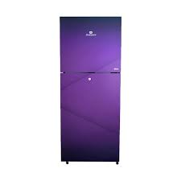

***Dawlance 160LF AVANTE+ Double Door Refrigerator***

* **Color:**Silver
* **Available:**Out of Stock
* **Dimension:**11*95*200
* **Compressor:**Inverter

**Old Price:**~~Rs 102,999.00~~

**New Price:**Rs 107,995.00